***PAAREES PERFUMES***

***Christian Diors***

***FOR UNISEX***

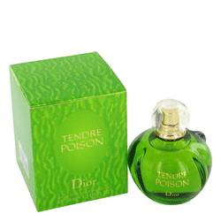

# *Tendre Poison*

***Description:***

Tendre Poison by Christian Dior Perfume. Channel your inner serpent with Tendre Poison, a scent that is both venomous and charming. The designers working for Christian Dior put this women's blend together in 1994. The foundation of Brazilian rosewood anchors swirls of honey, Mandarin orange and bergamot. There is even a touch of sharp asafoetida to give it a bit of bite. With plenty of brightness and a moderate silage, this fragrance works wonders when worn during the day or night.